**In IC Module**

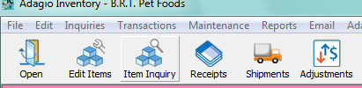

Enter the item # and the location it is being transferred from.

Enter the location it is being transferred to and the quantity being transferred.

Click ok.

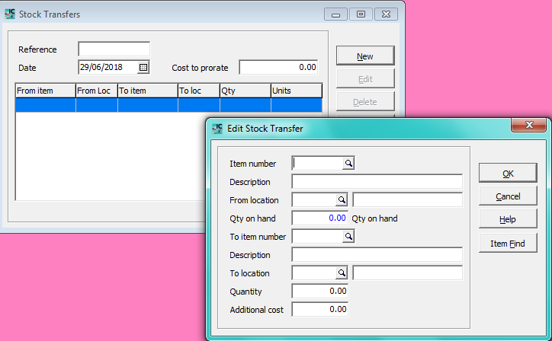

Enter all the items you want to transfer individually.

Select your batch. Post.

